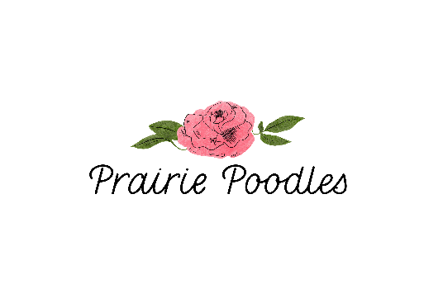

Prairie Poodles Sire Guardian Home INFO.

The guardian program is designed to benefit everyone involved, the puppy, the guardian home, and us. We are so thankful for our guardian homes and are always looking for amazing families that are interested, so that we can continue the successful way our breeding program works without ever needing to kennel raise a dog.

Poodles are social animals who adore their families, who want to be with them, and want to be involved in the daily happenings of the family. They deserve a loving family. We have poured our hearts into our puppies. Our puppies are born in our home and raised in our dining room.
​
Our Guardian Family get a puppy from us, and are compensated for being a part of our program. Our parent dogs retire with their forever family after their time in our program is complete.

We choose our future breeding dogs very carefully, and only those with qualities that we want to see continue are kept as our “pick of the litter” for breeding. Our guardian homes receive the best we have to offer when we place a potential future breeding dog with them. Not only are they receiving what we consider to be worthy of continuing a line, but we also completely health test the dogs, at our expense, when they are at the appropriate age. By the time one of our puppies is raised and tested to the strict standards we hold, we have invested a great deal into ensuring they are healthy and genetically sound.

How does it work?
When the dog has passed all required health, temperament, and structure the dog will be officially added to our program.

Benefits of the Guardian-Home Program
We are able to provide loving homes for all our beloved dogs where they can each receive the love of a family.
Guardian Homes get the opportunity to have a Poodle Puppy that is pick of the litter. (Estimated value of $7,000.00) Your cost is $1000.00.
You will have a pet that will have health testing completed at no cost to you.
Prairie Poodles will pay all vet costs for health testing associated with the breeding of the dog.
This agreement is to provide assurance that the Guardian Home Dog will thrive in her/his loving home, which is intended to be his/her forever home.

Initial Obligations of Guardian Family
In order to be considered for the Guardian Home Program, we require that you:
1. Live within 2 hours of Taber, Alberta.
2. Own your own home.
3. Have physical fencing to provide a safe and secure environment for the dog, unless Prairie Poodles approves other arrangements in writing.
4. Never leave the Dog off leash in an unsecured area. NO dog parks allowed. If the need for group play arises you may bring the Dog for playtime at Hidden Springs Pet Resort (Barnwell, AB) at your cost.
5. Have reliable transportation and willingness to bring the Dog to us when needed throughout the year for breeding purposes. (Testing, breeding, etc.)
6. Maintain open lines of communication with Prairie Poodles concerning any matter related to the Dog.
7. Keep the guardian Dog on food approved by Prairie Poodles.
8. Understand that Prairie Poodles may need to make decisions about your Guardian Dog and you will have to respect those decisions even if you do not agree.
ALL DECISIONS ARE ALWAYS FOR THE BETTERMENT OF THE DOG.
What is included when your puppy is delivered:
1. Pick of the litter Male puppy
2. Crate & Crate Bed
3. Full bag of our recommended puppy food.
4. ID tag for collar
5. Health Records, including microchip info.
6. Free Trupanion Pet Insurance Info.
7. Baxter & Bella Online Puppy School Discount Code.

Please contact us should you be interested in joining our Guardian Home Program!
We would love to hear from you!

